**Module Two Assignment**

**PUBLIC HEALTH AND EMERGENCY PREPAREDNESS**

**Submitted by: James G. Russell**

**Course Code: PGD007**

**Course Name: Post Graduate Diploma in Public Health**

**Admission Number: DDA/60/2019**

**Submitted to:**

**Development Dimensions Africa**

**School of Online and Distance Learning**

**Plaza, 3e etage, Parklands Limura Road**

**Nairobi Kenya**

**Submission Date: December 31, 2019**

Table of Content:

Discuss the principles of emergency preparedness ……………………….………. Page 3 - 5

Emergency preparedness process with diagram …………………………………... Page 6 – 9

Discussion on three potential impacts of emergencies on

communities and the immediate response/intervention for each …………………. Page 9 – 14

Describe the communication process identifying all those involved in the process … Page 14 - 17

What is the difference between hazard exposure and hazard vulnerability ……… Page 17 – 18

List and define the four phases of emergency management ……………………… Page 18 – 19

Reference………………………………………………..………………………… Page 20

Discuss the principles of emergency preparedness

* Is the responsibility of all: In emergency preparedness, every party should be involve, including Emergency managers and public health professionals who need to create a sustainable broad and sincere relationships among individuals, communities, national and local organizations to encourage trust among the population, advocate a team atmosphere, build consensus, and facilitate communication that will enable everyone to participate in the process and see it as ownership for sustainability through collaborative effect of all non-governmental private organizations and other stakeholders to have clear responsibilities through the process.
* Should be woven into the community and administrative context, and be undertaken at all administrative levels of both government and non-government organizations. In the context of this aspect of the principle of emergency preparedness, the key players like the public health personals and other emergency managers need to synchronize the activities of all relevant stakeholders to achieve a common goal or purpose and even know that every party is seeking a particular goal. Meaning tasks will be mapped and delegated among key parties to ensure that activities are well coordinated governments and non – governmental organization and not even leaving out the decisions of the community into the activities.
* Is an important aspect of all development policy and strategies: Public health personals and driving Emergency managers should value science- and knowledge-based approach based on education, training, experience, ethical practice, public stewardship, development policy of the strategies and implementation plan for continuous improvement and have in mind the sustainability aspect through a written policy and a strategic exit plan with the communities.
* Should be based on vulnerability assessment; the vulnerability assessment will clearly describe the magnitude of the emergency and even the most vulnerable population that will enable the public health personals and emergency managers to targets relevance areas or population during the intervention. The important issues in an emergency is to find out about interagency that is available and the humanitarian information centers which are often setup to provide and clean information of who is doing what and where to avoid investing much time in generating information that is already available and act accordingly to the community vulnerability status.
* Is connected to other aspects of emergency management; Based on required capabilities to respond to certain emergency, stakeholders should identify common capabilities applicable to all emergency situations. For example, operational communication during an incident could apply to a hurricane, an act of terrorism, or an earthquake. While approaches to operational communication may differ according to incident and circumstance that will be on ground.
* Should concentrate on process and people rather than documentation: In this aspect of emergency principal, the public health personnel or emergency managers are there to save lives and properties that are in danger and not putting their entire attention on documenting and so finding solutions that will save people who are danger and vulnerable will be the primary objectives of the public health personals and emergency managers rather than putting in more effect documenting the situations. The public health personnel and emergency manager’s major desires are to provide the greatest benefit for the greatest number of people, they should also keep in mind the particular needs of specific group, meaning more vulnerable population they serve.
* Should not be done in isolation: Forming a Collaborative Planning Team, this step formalizes a whole-of-community and all stakeholders approach and abilities to developing or updating emergency plans in response to a crisis. Forming this working group or team and involves clarifying the organizational leadership’s intent for such plans will enable every team player to perform excellently and even get better results.
* Should not concentrate only on disasters, but integrate prevention and response strategies for any scale of emergency. This principle validates the rationale for performing critical emergency response tasks. Representatives of the various stakeholders participating in the process of gathering and analyzing information, clarifying objectives, and finding different approaches to achieving objectives through integration of recovery services that will build population minds and understanding to live better after their recovery stage through the best strategies that will be offer to implement the organized pans. This process identifies resources to achieve key recovery tasks and other minds rehabilitation and integration.

With the help of a diagram describe the emergency preparedness process

The emergency preparedness process, which is a series of techniques for preparing a community, an organization, or an activity for emergencies with the help of the below diagram that starts with policy development, vulnerability assessment, developing emergencies plan, training and education and monitoring and evaluating the process through data collection and reporting. This preparedness process is all about turning awareness of risks faced by communities into sustainable actions that will makes their life much better.

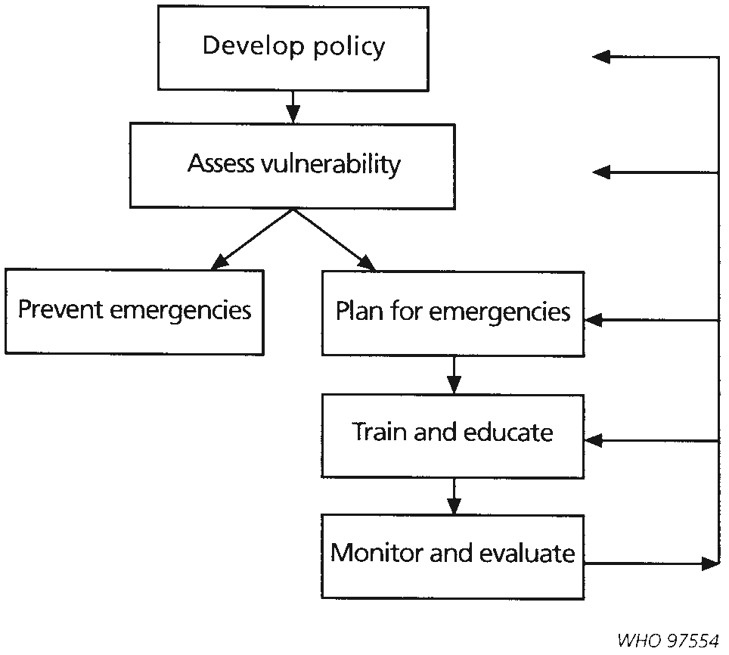

**Policy development** includes the development of emergency management legislation. Legislation is normally developed by a national government, and will mainly relate to responsibility for emergency preparedness and special emergency powers. There is also a need for provincial and community organizations to develop policy relating to their specific geographical area. Similarly, private organizations and NGOs with emergency management responsibilities should develop appropriate policy in full partnership and consultation with the local authorities. There is also a need for central government, provincial and community organizations to develop subsequent policies. Similarly, non-government organizations that have emergency management responsibilities should develop appropriate policy. (WHO 1999) Knowing a community which is composed of a group of people and the environment that supports them. For the purposes of policy development, communities and other stakeholders should be involving since they are the direct beneficiaries for realistic planning. Often planning will take place at several political or administrative levels simultaneously but having in mind community first.

**Vulnerability assessment** can be used by public health professionals and other emergency staff to determine the following:

* which parts of a community is most vulnerable to hazards and in what ways;
* which hazards may affect a community, and how they affect the community and its population;
* which aspects of the community should be modified to decrease vulnerability; and,
* which hazards should be considered for emergency prevention and preparedness.

A vulnerability assessment is also useful for response and recovery, as well as for prevention and preparedness, it can also be used again to:

* suggest areas that may sustain damage, and assist in measuring harm to the affected community;
* provide a baseline for recovery strategies, in that it will describe the ‘normal’ state of a community.

**Emergency planning:** Besides the major benefit of providing guidance during an emergency, developing the plan has other advantages. You may discover unrecognized hazardous conditions that would aggravate an emergency situation and you can work to eliminate them. The planning process may bring to light deficiencies, such as the lack of resources (equipment, trained personnel, supplies), or items that can be corrected before an emergency occurs. In addition, an emergency plan promotes safety awareness and shows the organization's commitment to the safety of the community or environment that is targeted.

Since emergencies will occur, preparation is necessary. An urgent need for rapid decisions, shortage of time, and lack of resources and trained personnel can lead to chaos during an emergency. Time and circumstances in an emergency mean that normal channels of authority and communication cannot be relied upon to function routinely. The stress of the situation can lead to poor judgment resulting in severe losses. A well thought out, well organized emergency response plan will help to eliminate these issues. (Canadian Centre for Occupational Health & safety/November 26, 2019)

**Emergency planning** consists of determining the following:

* response and recovery strategies to be implemented during and after emergencies;
* responsibility for these strategies;
* the management structure required for an emergency; and,
* the resource and information management

**Training and education** concerns training personnel in emergency management skills and knowledge, and informing the community of the actions that may be required during emergencies and how the community can participate in emergency management.

**Monitoring and evaluating** are methods for determining how well the preparedness program is being developed and implemented, and what needs to be done to improve it. Monitoring and evaluation can also ensure the appropriateness, effectiveness, and efficiency of emergency preparedness programs to determine how well the desire plan was delivered.

Discuss three potential impacts of emergencies on communities and the immediate response/intervention for each

###### **Disruption of services & infrastructure damage:** infrastructure are physical assets that play an essential role in the functioning of society and its economies, including facilities for electricity generation, accessing water and food, public facilities, telecommunication, education, sewage, electric systems, health and medical services and transportation. (Tom Michell & Emma Lovell March 2015) It is thus of utmost importance to ensure reliable and robust performance of infrastructures on a continuous basis to improve the country economics, particularly during and after the occurrence of extreme events. Large-scale armed conflict has been a long-term effect on population health here in Liberia the lead the disruption of services that the country is still recovering from. Many of those disruption has lead our friends and families into mental conditions due to issues they are still struggling to cope with due. Now criminal acts are moving toward legalization in the sense that when even they sealed from you and you need your items, you have the choice to meet with their commanding general so called CEO to register you stolen items by paying some amount that will enable him to investigate who stole your items and retrieve it then you pay some amount of money like buying it cheap from them. Now this has never happened before the war, police were there to protect lives and properties by offering services to the communities and people was happy to report stolen cases at the police station but now it’s turning around. After the war, many organizations proposals were accepted to move the country to recovery position but now the hope of the population is in the hands of the leadership. Due to bad leadership practice in Africa and other countries, the population hope has been dropped and situations are now used by political candidates to take government positions to enrich themselves. In addition to violence-related mortality, disruption in the delivery of basic services, including electricity, water and health care raises death rates among non-combatants during conflict and after it has ended. The collapsed health systems at the time, which suffer from flying of health workers to displaced sites, looting and physical destruction of facilities, exacerbates this indirect mortality. Although humanitarian organizations can alleviate suffering in the short run, repairing the health system is a more daunting task. The Liberian Civil War and the historical Ebola outbreak was the most talk about disruption of services and intrastation in the country. Many international partners and other international NGO’s was forced to fled the country because their business were interrupted. The rebels were burning properties, and even forcing properties from the real owners and if refused, they kill the people and take the property and so the population including service providers left the country and traveled to nearby countries to see refuge. In response to the post-war health challenges, the Ministry of Health and Social Welfare, with assistance from donors and international nongovernmental organizations (NGOs), embarked on rebuilding the health system. The ministry’s first aim was to expand the provision of primary health care, particularly in rural areas that were underserved even before the war. The 2007 National Health Plan outlined a basic package of health services: essential health services that would be provided without charge of fees at clinics and hospitals throughout the country, ranging from HIV testing to emergency obstetric care. The preventive and curative services in the basic package of health services target the disease burden in the country, particularly infectious disease and the high maternal and child morbidity and mortality. The ministry was partnering with a large group of international and national NGOs to deliver a basic package of health services but due to the civil war disruption that caused the rebels destroyed the country infrastructures like roads, schools, public buildings like governments offices and private homes were put on fires. Since Liberia economic is highly depending on donors funding, the nation was already in an agreement projects but the disruption shutdown every intervention. The Basic Package of Health Services (BPHS) was rollout for improving basic health services provision in a post-conflict setting like Liberia. Building upon successful implementation and strong health sector development, Later the Essential Package of Health Services (EPHS) was developed for including scaled-up and additional services for all levels of the health care delivery system to provide more comprehensive services to the Liberian people while EPHS also focuses on strengthening certain key areas that continue to perform weakly in the current system. As a public health personal, conducting vulnerability assessment, training frontline emergency staff and gathering materials for interventions will be my top priority. Ensuring that workforce understanding policies to avoid creating harm for the communities due to their vulnerability. Applying systems thinking to interventions and having in mind the protection and rescuing the community will be my priority. (Dr. Bernice T. Dahn et all BPHS 2007).

**Social disruption:** Disasters are non-routine events in societies that involve unifications of physical conditions with social definitions of human harm and social disruption. Social disruptions often lead to five social symptoms after disruption include: Frustration, Democratic Disconnection, Fragmentation, Polarization and Escalation. Studies from the last decade show, that our societies have become more fragmented and less coherent (e.g. Bishop 2008), neighborhoods turning into little states, organizing themselves to defend the local politics and culture against outsiders (Walzer 1983; Bauman 2017) and increasingly identifying through ways of voting, lifestyle or wellbeing (e.g. Schäfer 2015). Especially people on the more rights and left political spectrum are more likely to say it is important to them to live in a place where most people share their political views and have similar interests (Pew 2014). Hence, citizens become alienated from democratic consensus (Foa and Munk 2016; Levitsky and Ziblatt 2018) and tend to assume that their opponents believe more extreme things than they really do (Iyengar et al. 2012). Moreover, fear of being identified as unqualified, denied value and dignity and for that reason marginalized. At the same time, accelerations in liberal progression, globalization and migration flows have led to increasing polarized contestations about national identities - a volatile and critical social state, prone to conflict escalation (e.g. hate crimes after Brexit vote, incident at far-right rally in Charlottesville, USA). The sociological study of disasters requires attention to their special character as social problems (Fritz 1961, Hewitt 1983, Stallings 1995, Kreps and Drabek 1996, and Quarantelli 1998).

Restoring the community social lives by creating programs that will address community social needs through recreations like music and sport games and even adding the Self-Determination Theory strategic that has the potential of motivation and personality that will address three main issues like universal, innate and psychological needs in the life of the community by identifying their autonomy, mastery, and purpose. **(Deci and Ryan 2006)**

**Food shortage**: Is among the underlying causes of poverty, during emergency you will not be planning or saving for the future and it cause food shortage that makes you and the families vulnerable and may lead to earlier pregnancy among girl’s children, hard labor among males in their youth ages and compromise their learning ability, we need food to grow and think better and live better and develop our nations. People are living and having no hope of what will be there food for the day and even the next day to comes why their children need food and they have to provide for them and with shortage of food you cannot feed your families adequately, the community will experience hardship. Looking at the situation here in Liberia, which is a low level income Country that have limited access to education that should be preparing the citizens to overcome the challenges of shortages of food in the Country. Even though many Liberians have been receiving international scholarships to study aboard and return to improve the agricultural sector of this Country but due to the lack of commitment which is my own intelligent and bad leadership practice that have to do with closing the know and do gaps. Learning and not putting it into practice is what I called the know and do gaps. Education for public health professionals is about understanding issues that undermine population health and working the population to make them life better. So educating the community to start to have adequate knowledge on growing their common and available food and even Marketing the products. Working with stakeholders and other agriculture organizations like FAO to invest into human development by closing the gaps in food shortage. The 2014 – 2016 Ebola outbreak had a devastating effect on Liberia’s children and schools had to stay closed for most of the year to curb the spread of the disease (World Food Program Liberia Country Strategic Plan 2019- 2023). During this deadly epidemic the population could not freely move around to produce and store enough food and even the local had never had access to public health professionals that could equip them with knowledge to practice and provide for their families just by introducing the Human Centered Design which is an approach to problem solving, commonly used in **design** thinking and management frameworks that develops solutions to problems by involving the **human** perspective in all steps of the problem-solving process and even having the capability of working with communities to know that they are capable of producing what they need and what the society need and even generate better income from discovering their own skills. Making use of backyard garden process to produce food that will reduce the shortage of food and even contribute to the National Government poverty reduction strategies. (IMF Staff Country Report, July 7, 2008)

It is important to communicate with the public in anticipation of a disaster. Describe the communication process identifying all those involved in the process.

Communicating effectively with the public about specific threats is the key to successful emergency management and public health. It helps mitigate the risks, supports the implementation of protective actions, and contributes to minimizing negative mental health impacts of disasters Communications concerns the means of relaying information between organizations, people, and the community. Adequate communications are essential to all aspects of response and recovery of emergencies operations. The 'teachable moment' is a communication strategy that uses a current or timely health issue as an opportunity to educate the public about important health behaviours that can have a continuing impact on their lives. Receiving a flu shot educates the public about adherence to disaster medical interventions that protect and sustain health. During an emergency, timely and transparent production and dissemination of information generates trust and credibility so understanding the communication process is vector in working in emergency situations. National authorities, international agencies, humanitarian assistance organizations, the affected population, and the communication media will demand information in the form of data, figures, reports, and situation analysis or recommendations. These stakeholders depend on this information to guide their work and to translate their interest and concern into concrete action. The capacity to change behaviour is a recognized role for public policy professionals and enhances their involvement in policy development and communication for emergency planning and management. The description of the communication outlined below with the parties involved.

* coverage from community to provincial and national levels, both within and between organizations;
* primary reliance on existing systems and compatibility between organizations’ systems;
* dedicated frequencies for command, control and coordination;
* back-up systems and back-up power supplies; and,
* simplicity of activation and operation.
* Facilitate dialogue among different actors
* Produce, analyze, and organize information
* Promote and stimulate work on the team and in multicultural settings
* Work under pressure
* Make decisions as a team
* Manage politically sensitive situations
* Have both oral and written communication skills
* Prepare and carry out communication strategies that respond to the needs and demands of key actors
* Design, execute, and evaluate communication plans
* Manage computer equipment and software programs
* Be fluent in official and local languages and have interpreters

The following key stakeholders which include but not limited to government and its parastatal, NGOs, donors, the private sector, media, academia, regional cooperation, Community Based Organizations, community/citizen and the immediate environment should strongly be involved in the disaster and emergencies situations. (Saeed AL-Fazari1*, and Narimah Kasim MATEC Web of Conferences, 2019)

Define the term hazard,

**Hazard** can be defined as a phenomenon which has the potential to cause disruption or damage to humans and their environment. A hazard can also be defined as a dangerous phenomenon, substance, human activity or condition that may cause loss of life, injury or other health impacts, property damage, loss of livelihoods and services, social and economic disruption, or environmental damages. Again Under the Health Protection and Promotion Act, a health hazard is a condition of a premises, a substance, thing, plant or animal other than man, or a solid, liquid, gas or combination of any of them, that has or that is likely to have an adverse effect on the health of any person. (Macleod M. Southeastern Public Health Oct. 24, 2019)

What is the difference between hazard exposure and hazard vulnerability?

Exposure refers to people, property, systems, or other elements present in hazard zones that are nearby subject to potential losses; again **Hazard exposure** is a state of being in a situation which a person or a group of people remain in an imminent risk of danger in some surroundings. Such dangers are related to the workplace health safety and environmental or our day to day interaction for life While **Vulnerability** is the result of a number of factors that increases the chance of a community being unable to cope with an emergency. Vulnerability refers to the characteristics and circumstances of a community, system or asset that make it susceptible to the damaging effects of a hazard.

It is again possible to be exposed and not vulnerable (for example by living in a floodplain but having sufficient means to modify building structure and behavior to mitigate potential loss). However, to be vulnerable to an extreme event, it is necessary to also be exposed.There are many aspects of vulnerability, arising from various physical, social, economic, and environmental factors. Examples may include poor design and construction of buildings, inadequate protection of assets, lack of public information and awareness, limited official recognition of risks and preparedness measures, and disregard for wise environmental management. Vulnerability varies significantly within a community and over time.

Not all sections of a community are vulnerable to hazards, but most are vulnerable to some degree. Vulnerability consists of two aspects - susceptibility and resilience. **Susceptibility** concerns the factors of a community which allow a hazard to cause an emergency, e.g. living in an earthquake-prone area or the level of development of the community. **Resilience** is the ability of a community to withstand the damage caused by emergencies, including all factors that allow the community to respond and recover from emergencies.

So the different is that, for exposure is what putting you at risks while vulnerability is the number of conditions that increases the chances of an individuals or community be able to cope with an emergency.

List and define the four phases of emergency management: The Emergency Management is to protects communities by coordinating and integrating all activities necessary to build, sustain, and improve the capability to mitigate against, prepare for, respond to, and recover from threats or disasters, acts of terrorism, or other man-made disasters, the four phrases of emergency management include:

|  |  |
| --- | --- |
| Mitigation | This phase includes any activities for preventing an emergency situations and even reduce the likelihood of occurrence, or reduce the damaging effects of unavoidable hazards. Mitigation activities should be measure by developing and emergency plan before an emergency intervention.  For example, to mitigate fire in your home, follow safety standards in selecting building materials, wiring, and appliances. But, an accident involving fire could happen. |
| Preparedness | This phase includes developing plans for what to do that will save the population and the environment, where to go, or who to call for help before an event occurs; actions that will improve your chances successfully when dealing with an emergency. For instance, posting emergency telephone numbers, holding disaster drills, and installing smoke detectors are all preparedness measures. You should also consider preparing a disaster kit with essential supplies for your family. |
| Response | Your safety and well-being in an emergency depend on how prepare you and how you will respond to a crisis being able to act responsibly and safely to community and the environment. emergency managers and public health professionals uses creative and innovative approaches in solving disaster challenges among the population. |
| Recovery | After an emergency and once the immediate danger is over, you continue safety and well-being will depend on your ability to cope with rearranging your life and environment. During the recovery period, you must take care of yourself and the environment to prevent stress-related illnesses and excessive financial burdens. During recovery, you should also consider things to do that would lessen the effects of future disasters and such process is called the recovery stage. |

References:

World Health Organization (1994) *From Disaster Management to Sustainable Development: How the Public Sector, Private Sector and Voluntary Organizations Can Work Together*, Geneva

Kepner-Tregoe, Inc. *Project Management*, 1987

based on EPR Programme, Ministry of Health and Family Welfare (1996) *Emergency Country Profile*, Bangladesh

Emergency Management Australia (1995) *National Emergency Management Competency Standards,* Canberra, Australia

Emergency Preparedness Unit, Division of Emergency and Humanitarian Action, World Health

Organization (1994) *Planning for Emergencies - Emergency Preparedness Programs*, Geneva

adapted from table called ‘Loss Parameters for Risk Analysis’ in United Nations Disaster Relief

Organization (1992) *An Overview of Disaster Management,* Geneva

Dale, P.F. & McLaughlin, J.D. (1988) *Land Information Management: An Introduction with Special Reference to Cadastral Problems in Third World Countries,* Clarendon Press, Oxford

Kepner-Tregoe, Inc. *(*1987) *Project Management*

W.N.Carter (1991) *Disaster Management: A Disaster Manager’s Handbook* Asian Development Bank, Manila

Emergency Preparedness Unit, Division of Emergency and Humanitarian Action, World Health Organization. *Planning for Emergencies Part 9 - Intersectoral Planning*, Geneva,1995, draft